R Assignment 2

2023-03-15

library(readr)  
library(tidyr)  
library(dplyr)

##   
## Attaching package: 'dplyr'

## The following objects are masked from 'package:stats':  
##   
## filter, lag

## The following objects are masked from 'package:base':  
##   
## intersect, setdiff, setequal, union

library(lattice)  
library(ggplot2)  
  
df<- read_csv("R_ass2.csv")

## Rows: 24 Columns: 30

## ── Column specification ────────────────────────────────────────────────────────  
## Delimiter: ","  
## chr (1): Insurer  
## dbl (29): Sl No., feb2022_pre, feb2023_pre, Growth_pre, uptoFeb2022_pre, upt...  
##   
## ℹ Use `spec()` to retrieve the full column specification for this data.  
## ℹ Specify the column types or set `show_col_types = FALSE` to quiet this message.

summary(df)

## Sl No. Insurer feb2022_pre feb2023_pre   
## Min. : 1.00 Length:24 Min. : 0.00 Min. : 0.00   
## 1st Qu.: 6.75 Class :character 1st Qu.: 62.65 1st Qu.: 70.75   
## Median :12.50 Mode :character Median : 230.59 Median : 236.19   
## Mean :12.50 Mean : 1144.38 Mean : 951.99   
## 3rd Qu.:18.25 3rd Qu.: 603.00 3rd Qu.: 742.37   
## Max. :24.00 Max. :17489.34 Max. :11879.49   
##   
## Growth_pre uptoFeb2022_pre uptofeb2023_pre tgrowth_pre   
## Min. :-100.00 Min. : 0.0 Min. : 0.0 Min. :-60.180   
## 1st Qu.: 0.74 1st Qu.: 605.9 1st Qu.: 575.1 1st Qu.: 7.435   
## Median : 9.45 Median : 1860.5 Median : 2540.5 Median : 15.350   
## Mean : 26.55 Mean : 10610.6 Mean : 13269.2 Mean : 20.089   
## 3rd Qu.: 25.18 3rd Qu.: 5205.3 3rd Qu.: 6674.0 3rd Qu.: 32.665   
## Max. : 264.69 Max. :156440.6 Max. :203182.9 Max. :125.960   
## NA's :1 NA's :1   
## marketshare_pre feb2022_no_policy feb2023_no_policy Growth_no_policy   
## Min. : 0.0000 Min. : 0 Min. : 0 Min. :-100.000   
## 1st Qu.: 0.1775 1st Qu.: 7212 1st Qu.: 3615 1st Qu.: -4.605   
## Median : 0.8000 Median : 18634 Median : 19870 Median : -0.960   
## Mean : 4.1662 Mean : 112468 Mean : 95230 Mean : 2.027   
## 3rd Qu.: 2.0925 3rd Qu.: 46680 3rd Qu.: 50621 3rd Qu.: 6.910   
## Max. :63.8000 Max. :2036642 Max. :1616048 Max. : 72.730   
## NA's :1   
## uptoFeb2022policy uptofeb2023_no_policy tgrowth_no_policy  
## Min. : 0 Min. : 0 Min. :-75.44   
## 1st Qu.: 49615 1st Qu.: 43949 1st Qu.: -4.64   
## Median : 169050 Median : 187710 Median : 6.74   
## Mean : 963300 Mean : 967281 Mean : 3.75   
## 3rd Qu.: 409915 3rd Qu.: 487412 3rd Qu.: 17.36   
## Max. :16854304 Max. :16408649 Max. : 51.59   
## NA's :1   
## marketshare_no_policy feb2022_no_of_live feb2023_no_of_live Growth_no_of_live  
## Min. : 0.000 Min. : 0 Min. : 0 Min. :-100.00   
## 1st Qu.: 0.185 1st Qu.: 14986 1st Qu.: 21788 1st Qu.: -4.26   
## Median : 0.805 Median : 166734 Median : 284635 Median : 20.35   
## Mean : 4.166 Mean : 774824 Mean : 949702 Mean : 127.74   
## 3rd Qu.: 2.098 3rd Qu.: 613075 3rd Qu.: 931086 3rd Qu.: 120.95   
## Max. :70.680 Max. :5226886 Max. :6270068 Max. :1015.14   
## NA's :1   
## uptoFeb2022_no_of_live uptofeb2023_no_of_live tgrowth_no_of_live  
## Min. : 0 Min. : 0 Min. :-86.78   
## 1st Qu.: 288476 1st Qu.: 291985 1st Qu.: 9.52   
## Median : 2157526 Median : 2987659 Median : 26.36   
## Mean : 7420057 Mean : 9393884 Mean : 31.82   
## 3rd Qu.: 6564602 3rd Qu.: 9477600 3rd Qu.: 52.51   
## Max. :45313866 Max. :57257255 Max. :138.14   
## NA's :1   
## marketshare_no_of_live feb2022_sum_assured feb2023_sum_assured  
## Min. : 0.000 Min. : 0 Min. : 0   
## 1st Qu.: 0.130 1st Qu.: 1765 1st Qu.: 1921   
## Median : 1.325 Median : 9136 Median : 15234   
## Mean : 4.166 Mean :19585 Mean : 27939   
## 3rd Qu.: 4.200 3rd Qu.:30185 3rd Qu.: 39842   
## Max. :25.400 Max. :71246 Max. :117590   
##   
## Growth_sum_assured uptoFeb2022_sum_assured uptofeb2023_sum_assured  
## Min. :-100.000 Min. : 0 Min. : 0   
## 1st Qu.: -9.655 1st Qu.: 24474 1st Qu.: 22665   
## Median : 23.570 Median :136556 Median :149481   
## Mean : 54.818 Mean :211421 Mean :258742   
## 3rd Qu.: 92.050 3rd Qu.:273702 3rd Qu.:357298   
## Max. : 487.770 Max. :859600 Max. :966683   
## NA's :1   
## tgrowth_sum_assured marketshare_sum_assured  
## Min. :-95.180 Min. : 0.000   
## 1st Qu.: -4.005 1st Qu.: 0.365   
## Median : 12.460 Median : 2.405   
## Mean : 11.452 Mean : 4.167   
## 3rd Qu.: 32.975 3rd Qu.: 5.753   
## Max. : 72.840 Max. :15.570   
## NA's :1

str(df)

## spc_tbl_ [24 × 30] (S3: spec_tbl_df/tbl_df/tbl/data.frame)  
## $ Sl No. : num [1:24] 1 2 3 4 5 6 7 8 9 10 ...  
## $ Insurer : chr [1:24] "Aditya Birla Sun Life" "Aegas Federal Life" "Aegon Life" "Aviva Life" ...  
## $ feb2022_pre : num [1:24] 445.05 67.67 0.43 25.73 879.54 ...  
## $ feb2023_pre : num [1:24] 612.62 78.13 1.55 31.13 929.88 ...  
## $ Growth_pre : num [1:24] 37.65 15.46 264.69 21 5.72 ...  
## $ uptoFeb2022_pre : num [1:24] 4655.2 682.4 16.4 229.4 7463.6 ...  
## $ uptofeb2023_pre : num [1:24] 6441.38 780.86 6.55 253.77 9060.83 ...  
## $ tgrowth_pre : num [1:24] 38.4 14.4 -60.2 10.6 21.4 ...  
## $ marketshare_pre : num [1:24] 2.02 0.25 0 0.08 2.85 0.26 1.01 0.12 0.14 0.17 ...  
## $ feb2022_no_policy : num [1:24] 18368 3649 242 1943 45462 ...  
## $ feb2023_no_policy : num [1:24] 19363 3656 418 2788 55923 ...  
## $ Growth_no_policy : num [1:24] 5.42 0.19 72.73 43.49 23.01 ...  
## $ uptoFeb2022policy : num [1:24] 189869 37286 8731 17438 399437 ...  
## $ uptofeb2023_no_policy : num [1:24] 202664 40337 2144 23237 520287 ...  
## $ tgrowth_no_policy : num [1:24] 6.74 8.18 -75.44 33.25 30.26 ...  
## $ marketshare_no_policy : num [1:24] 0.87 0.17 0.01 0.1 2.24 0.38 0.66 0.19 0.26 0.15 ...  
## $ feb2022_no_of_live : num [1:24] 337686 2855 5331 16179 2489059 ...  
## $ feb2023_no_of_live : num [1:24] 442264 6407 22765 140759 2370738 ...  
## $ Growth_no_of_live : num [1:24] 30.97 124.41 327.03 770.01 -4.75 ...  
## $ uptoFeb2022_no_of_live : num [1:24] 2118054 25245 60958 237009 25041393 ...  
## $ uptofeb2023_no_of_live : num [1:24] 5044010 32325 55141 522275 24190243 ...  
## $ tgrowth_no_of_live : num [1:24] 138.14 28.05 -9.54 120.36 -3.4 ...  
## $ marketshare_no_of_live : num [1:24] 2.24 0.01 0.02 0.23 10.73 ...  
## $ feb2022_sum_assured : num [1:24] 19777 1229 1813 1209 50572 ...  
## $ feb2023_sum_assured : num [1:24] 41502 1281 285 2858 39289 ...  
## $ Growth_sum_assured : num [1:24] 109.85 4.25 -84.28 136.3 -22.31 ...  
## $ uptoFeb2022_sum_assured: num [1:24] 184042 11019 25071 13691 423501 ...  
## $ uptofeb2023_sum_assured: num [1:24] 318107 14038 1207 21976 474870 ...  
## $ tgrowth_sum_assured : num [1:24] 72.8 27.4 -95.2 60.5 12.1 ...  
## $ marketshare_sum_assured: num [1:24] 5.12 0.23 0.02 0.35 7.65 0.32 2.61 0.14 0.85 0.46 ...  
## - attr(*, "spec")=  
## .. cols(  
## .. `Sl No.` = col_double(),  
## .. Insurer = col_character(),  
## .. feb2022_pre = col_double(),  
## .. feb2023_pre = col_double(),  
## .. Growth_pre = col_double(),  
## .. uptoFeb2022_pre = col_double(),  
## .. uptofeb2023_pre = col_double(),  
## .. tgrowth_pre = col_double(),  
## .. marketshare_pre = col_double(),  
## .. feb2022_no_policy = col_double(),  
## .. feb2023_no_policy = col_double(),  
## .. Growth_no_policy = col_double(),  
## .. uptoFeb2022policy = col_double(),  
## .. uptofeb2023_no_policy = col_double(),  
## .. tgrowth_no_policy = col_double(),  
## .. marketshare_no_policy = col_double(),  
## .. feb2022_no_of_live = col_double(),  
## .. feb2023_no_of_live = col_double(),  
## .. Growth_no_of_live = col_double(),  
## .. uptoFeb2022_no_of_live = col_double(),  
## .. uptofeb2023_no_of_live = col_double(),  
## .. tgrowth_no_of_live = col_double(),  
## .. marketshare_no_of_live = col_double(),  
## .. feb2022_sum_assured = col_double(),  
## .. feb2023_sum_assured = col_double(),  
## .. Growth_sum_assured = col_double(),  
## .. uptoFeb2022_sum_assured = col_double(),  
## .. uptofeb2023_sum_assured = col_double(),  
## .. tgrowth_sum_assured = col_double(),  
## .. marketshare_sum_assured = col_double()  
## .. )  
## - attr(*, "problems")=<externalptr>

df1 <- slice(df, c(-24,-19))  
  
premium=select(df1,c(1,2,3,4,5,6,7,8,9))  
no_policy=select(df1,c(1,2,10,11,12,13,14,15,16))  
no_live=select(df1,c(1,2,17,18,19,20,21,22,23))  
sum_assured=select(df1,c(1,2,24,25,26,27,28,29,30))  
  
summary(premium)

## Sl No. Insurer feb2022_pre feb2023_pre   
## Min. : 1.00 Length:22 Min. : 0.43 Min. : 0.00   
## 1st Qu.: 6.25 Class :character 1st Qu.: 68.86 1st Qu.: 81.78   
## Median :11.50 Mode :character Median : 230.59 Median : 236.19   
## Mean :11.68 Mean : 453.45 Mean : 498.55   
## 3rd Qu.:16.75 3rd Qu.: 553.25 3rd Qu.: 717.98   
## Max. :23.00 Max. :2076.48 Max. :2272.72   
## Growth_pre uptoFeb2022_pre uptofeb2023_pre tgrowth_pre   
## Min. :-100.000 Min. : 16.44 Min. : 6.55 Min. :-60.180   
## 1st Qu.: 2.288 1st Qu.: 705.05 1st Qu.: 631.29 1st Qu.: 7.263   
## Median : 10.600 Median : 1860.45 Median : 2540.47 Median : 14.890   
## Mean : 29.214 Mean : 4464.24 Mean : 5239.95 Mean : 19.644   
## 3rd Qu.: 27.192 3rd Qu.: 4741.43 3rd Qu.: 6541.31 3rd Qu.: 33.188   
## Max. : 264.690 Max. :22613.36 Max. :26084.12 Max. :125.960   
## marketshare_pre   
## Min. :0.0000   
## 1st Qu.:0.1975   
## Median :0.8000   
## Mean :1.6450   
## 3rd Qu.:2.0500   
## Max. :8.1900

summary(no_policy)

## Sl No. Insurer feb2022_no_policy feb2023_no_policy  
## Min. : 1.00 Length:22 Min. : 242 Min. : 0   
## 1st Qu.: 6.25 Class :character 1st Qu.: 9030 1st Qu.: 4744   
## Median :11.50 Mode :character Median : 18634 Median : 19870   
## Mean :11.68 Mean : 30117 Mean : 30431   
## 3rd Qu.:16.75 3rd Qu.: 42571 3rd Qu.: 45893   
## Max. :23.00 Max. :163783 Max. :158068   
## Growth_no_policy uptoFeb2022policy uptofeb2023_no_policy tgrowth_no_policy  
## Min. :-100.000 Min. : 8731 Min. : 2144 Min. :-75.440   
## 1st Qu.: -4.570 1st Qu.: 65524 1st Qu.: 49208 1st Qu.: -5.625   
## Median : -0.405 Median : 169050 Median : 187710 Median : 7.460   
## Mean : 3.057 Mean : 284768 Mean : 309368 Mean : 4.040   
## 3rd Qu.: 7.655 3rd Qu.: 365782 3rd Qu.: 429606 3rd Qu.: 18.517   
## Max. : 72.730 Max. :1658171 Max. :1907406 Max. : 51.590   
## marketshare_no_policy  
## Min. :0.0100   
## 1st Qu.:0.2075   
## Median :0.8050   
## Mean :1.3323   
## 3rd Qu.:1.8500   
## Max. :8.2200

summary(no_live)

## Sl No. Insurer feb2022_no_of_live feb2023_no_of_live  
## Min. : 1.00 Length:22 Min. : 2855 Min. : 0   
## 1st Qu.: 6.25 Class :character 1st Qu.: 17975 1st Qu.: 29222   
## Median :11.50 Mode :character Median : 166734 Median : 284635   
## Mean :11.68 Mean : 768491 Mean : 975039   
## 3rd Qu.:16.75 3rd Qu.: 461411 3rd Qu.: 714686   
## Max. :23.00 Max. :5226886 Max. :6270068   
## Growth_no_of_live uptoFeb2022_no_of_live uptofeb2023_no_of_live  
## Min. :-100.00 Min. : 25245 Min. : 32325   
## 1st Qu.: -1.80 1st Qu.: 321875 1st Qu.: 335417   
## Median : 25.66 Median : 2157526 Median : 2987659   
## Mean : 134.48 Mean : 7017960 Mean : 9027075   
## 3rd Qu.: 122.68 3rd Qu.: 5488817 3rd Qu.: 7161182   
## Max. :1015.14 Max. :45313866 Max. :57257255   
## tgrowth_no_of_live marketshare_no_of_live  
## Min. :-86.780 Min. : 0.010   
## 1st Qu.: 8.715 1st Qu.: 0.150   
## Median : 27.205 Median : 1.325   
## Mean : 32.656 Mean : 4.004   
## 3rd Qu.: 55.337 3rd Qu.: 3.172   
## Max. :138.140 Max. :25.400

summary(sum_assured)

## Sl No. Insurer feb2022_sum_assured feb2023_sum_assured  
## Min. : 1.00 Length:22 Min. : 911 Min. : 0   
## 1st Qu.: 6.25 Class :character 1st Qu.: 1936 1st Qu.: 2234   
## Median :11.50 Mode :character Median : 9136 Median : 15234   
## Mean :11.68 Mean :18127 Mean : 27687   
## 3rd Qu.:16.75 3rd Qu.:27806 3rd Qu.: 37000   
## Max. :23.00 Max. :62518 Max. :117590   
## Growth_sum_assured uptoFeb2022_sum_assured uptofeb2023_sum_assured  
## Min. :-100.000 Min. : 11019 Min. : 1207   
## 1st Qu.: -4.718 1st Qu.: 25842 1st Qu.: 24257   
## Median : 32.605 Median :136556 Median :149481   
## Mean : 57.936 Mean :191568 Mean :238323   
## 3rd Qu.: 94.030 3rd Qu.:251768 3rd Qu.:312519   
## Max. : 487.770 Max. :679052 Max. :931338   
## tgrowth_sum_assured marketshare_sum_assured  
## Min. :-95.180 Min. : 0.0200   
## 1st Qu.: -5.732 1st Qu.: 0.3925   
## Median : 15.500 Median : 2.4050   
## Mean : 11.406 Mean : 3.8382   
## 3rd Qu.: 35.062 3rd Qu.: 5.0300   
## Max. : 72.840 Max. :15.0000

histogram(~feb2022_pre,data = df1,col=c('red','yellow','green'))

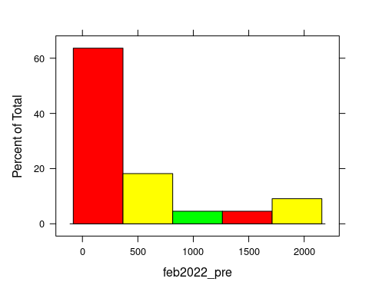

ggplot(premium,aes(Insurer,feb2022_pre))+geom_bar(stat="identity",position = "dodge")+theme(axis.text.x = element_text(angle = 90))

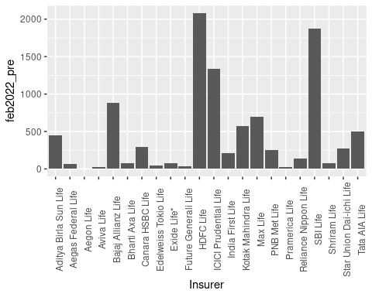

ggplot(premium,aes(Insurer,feb2023_pre))+geom_bar(stat="identity",position = "dodge")+theme(axis.text.x = element_text(angle = 90))

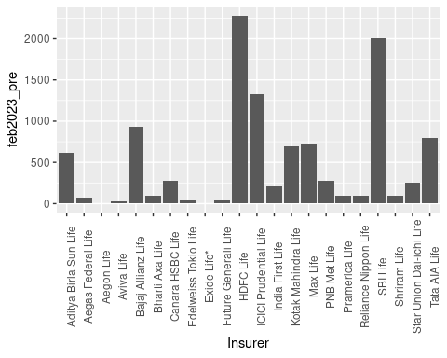

library(tidyr)  
#premium comparision of different companies  
  
#comparision between 2022 premium vs 2023 premium  
df_long <- gather(df1, key ='feb2022_pre', value = "value", 'feb2022_pre', 'feb2023_pre')  
ggplot(data = df_long, aes(x = Insurer, y = value, fill = feb2022_pre)) +  
 geom_bar(stat = "identity", position = position_dodge())+theme(axis.text.x = element_text(angle = 90))

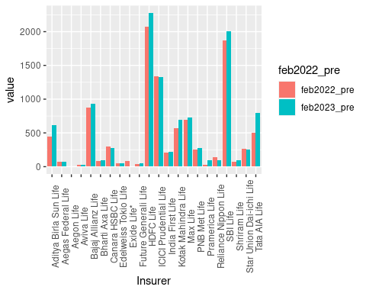

#growth of premium  
ggplot(premium,aes(Insurer,Growth_pre))+geom_bar(stat="identity",position = "dodge")+theme(axis.text.x = element_text(angle = 90))

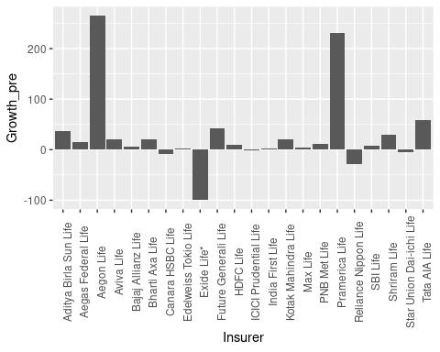

#comparision between 2022 premium vs 2023 premium  
df_pre <- gather(premium, key ='uptoFeb2022_pre', value = "value", 'uptoFeb2022_pre', 'uptofeb2023_pre')  
ggplot(data = df_pre, aes(x = Insurer, y = value, fill = uptoFeb2022_pre)) +  
 geom_bar(stat = "identity", position = position_dodge())+theme(axis.text.x = element_text(angle = 90))

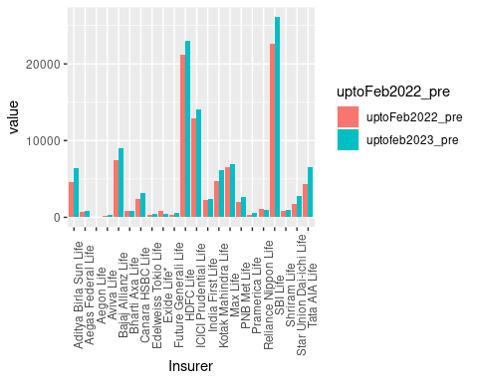

#growth of total premium  
ggplot(premium,aes(Insurer,tgrowth_pre))+geom_bar(stat="identity",position = "dodge")+theme(axis.text.x = element_text(angle = 90))

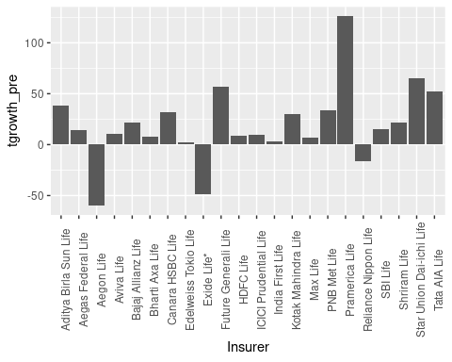

#no of policy comparision of different companies  
  
#comparision between 2022 no of policy vs 2023 no of policy  
df_pol <- gather(df1, key ='feb2022_no_policy', value = "value", 'feb2022_no_policy', 'feb2023_no_policy')  
ggplot(data = df_pol, aes(x = Insurer, y = value, fill = feb2022_no_policy)) +  
 geom_bar(stat = "identity", position = position_dodge())+theme(axis.text.x = element_text(angle = 90))

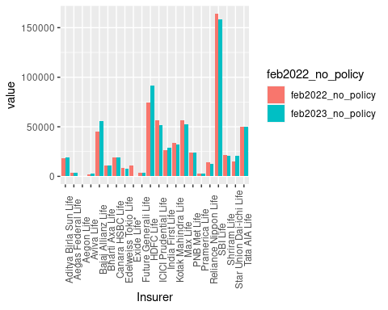

#growth of no of policy  
ggplot(no_policy,aes(Insurer,Growth_no_policy))+geom_bar(stat="identity",position = "dodge")+theme(axis.text.x = element_text(angle = 90))

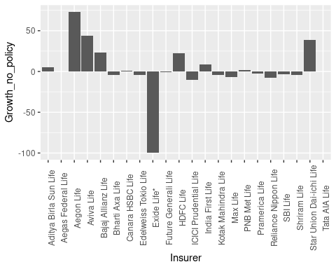

#comparision between 2022 no of policy vs 2023 no of policy  
df_pol1 <- gather(no_policy, key ='uptoFeb2022policy', value = "value", 'uptoFeb2022policy', 'uptofeb2023_no_policy')  
ggplot(data = df_pol1, aes(x = Insurer, y = value, fill = uptoFeb2022policy)) +  
 geom_bar(stat = "identity", position = position_dodge())+theme(axis.text.x = element_text(angle = 90))

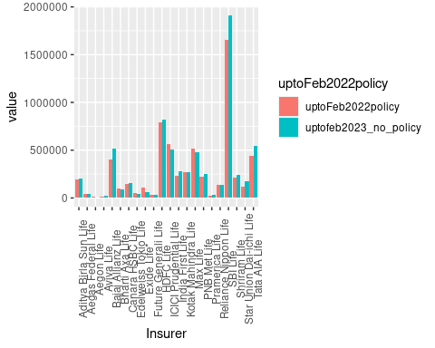

#growth of total no of policy  
ggplot(no_policy,aes(Insurer,tgrowth_no_policy))+geom_bar(stat="identity",position = "dodge")+theme(axis.text.x = element_text(angle = 90))

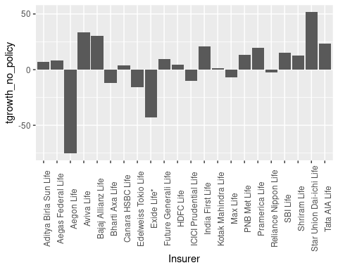

#no of lives comparision of different companies  
#comparision between 2022 no of lives vs 2023 no of lives  
df_live <- gather(df1, key ='feb2022_no_of_live', value = "value", 'feb2022_no_of_live', 'feb2023_no_of_live')  
ggplot(data = df_live, aes(x = Insurer, y = value, fill = feb2022_no_of_live)) +  
 geom_bar(stat = "identity", position = position_dodge())+theme(axis.text.x = element_text(angle = 90))

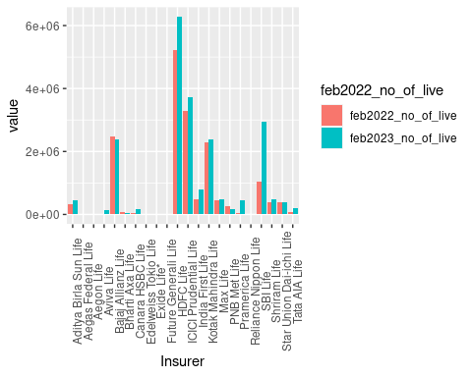

#growth of no of lives  
ggplot(df1,aes(Insurer,Growth_pre))+geom_bar(stat="identity",position = "dodge")+theme(axis.text.x = element_text(angle = 90))



#comparision between 2022 no of lives vs 2023 no of lives  
df_live1 <- gather(df1, key ='uptoFeb2022_no_of_live', value = "value", 'uptoFeb2022_no_of_live', 'uptofeb2023_no_of_live')  
ggplot(data = df_live1, aes(x = Insurer, y = value, fill = uptoFeb2022_no_of_live)) +  
 geom_bar(stat = "identity", position = position_dodge())+theme(axis.text.x = element_text(angle = 90))

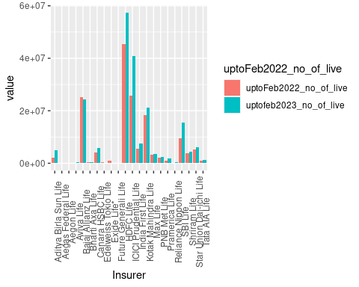

#growth of total premium  
ggplot(df1,aes(Insurer,tgrowth_no_of_live))+geom_bar(stat="identity",position = "dodge")+theme(axis.text.x = element_text(angle = 90))

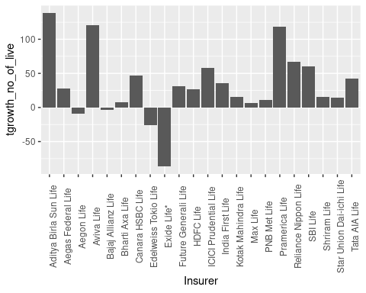

#sum assured comparision of different companies  
#comparision between 2022 sum assured vs 2023 sum assured  
df_sa <- gather(df1, key ='feb2022_sum_assured', value = "value", 'feb2022_sum_assured', 'feb2023_sum_assured')  
ggplot(data = df_sa, aes(x = Insurer, y = value, fill = feb2022_sum_assured)) +  
 geom_bar(stat = "identity", position = position_dodge())+theme(axis.text.x = element_text(angle = 90))

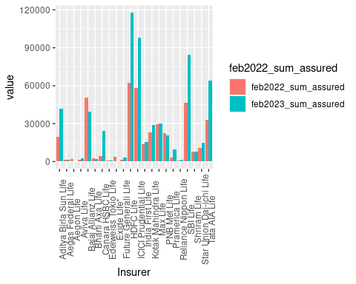

#growth of sum assured  
ggplot(premium,aes(Insurer,Growth_pre))+geom_bar(stat="identity",position = "dodge")+theme(axis.text.x = element_text(angle = 90))



#comparision between upto 2022 sum assured vs 2023 sum assured  
df_sa <- gather(df1, key ='uptoFeb2022_sum_assured', value = "value", 'uptoFeb2022_sum_assured', 'uptofeb2023_sum_assured')  
ggplot(data = df_sa, aes(x = Insurer, y = value, fill = uptoFeb2022_sum_assured)) +  
 geom_bar(stat = "identity", position = position_dodge())+theme(axis.text.x = element_text(angle = 90))

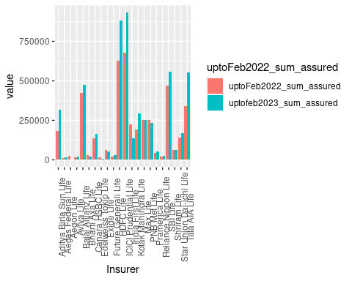

#growth of total sum assured  
ggplot(df1,aes(Insurer,tgrowth_sum_assured))+geom_bar(stat="identity",position = "dodge")+theme(axis.text.x = element_text(angle = 90))

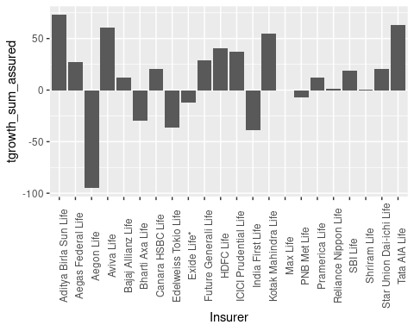

k2=select(df1,c(3,10,17,24))  
summary(k2)

## feb2022_pre feb2022_no_policy feb2022_no_of_live feb2022_sum_assured  
## Min. : 0.43 Min. : 242 Min. : 2855 Min. : 911   
## 1st Qu.: 68.86 1st Qu.: 9030 1st Qu.: 17975 1st Qu.: 1936   
## Median : 230.59 Median : 18634 Median : 166734 Median : 9136   
## Mean : 453.45 Mean : 30117 Mean : 768491 Mean :18127   
## 3rd Qu.: 553.25 3rd Qu.: 42571 3rd Qu.: 461411 3rd Qu.:27806   
## Max. :2076.48 Max. :163783 Max. :5226886 Max. :62518

k3=select(df1,c(4,11,18,25))  
summary(k3)

## feb2023_pre feb2023_no_policy feb2023_no_of_live feb2023_sum_assured  
## Min. : 0.00 Min. : 0 Min. : 0 Min. : 0   
## 1st Qu.: 81.78 1st Qu.: 4744 1st Qu.: 29222 1st Qu.: 2234   
## Median : 236.19 Median : 19870 Median : 284635 Median : 15234   
## Mean : 498.55 Mean : 30431 Mean : 975039 Mean : 27687   
## 3rd Qu.: 717.98 3rd Qu.: 45893 3rd Qu.: 714686 3rd Qu.: 37000   
## Max. :2272.72 Max. :158068 Max. :6270068 Max. :117590

share=select(df1,c(9,16,23,30))  
summary(share)

## marketshare_pre marketshare_no_policy marketshare_no_of_live  
## Min. :0.0000 Min. :0.0100 Min. : 0.010   
## 1st Qu.:0.1975 1st Qu.:0.2075 1st Qu.: 0.150   
## Median :0.8000 Median :0.8050 Median : 1.325   
## Mean :1.6450 Mean :1.3323 Mean : 4.004   
## 3rd Qu.:2.0500 3rd Qu.:1.8500 3rd Qu.: 3.172   
## Max. :8.1900 Max. :8.2200 Max. :25.400   
## marketshare_sum_assured  
## Min. : 0.0200   
## 1st Qu.: 0.3925   
## Median : 2.4050   
## Mean : 3.8382   
## 3rd Qu.: 5.0300   
## Max. :15.0000

pre=select(df1,c(3,4,9))  
pol=select(df1,c(10,11,16))  
live=select(df1,c(17,18,23))  
sa=select(df1,c(24,25,30))  
cor(k2)

## feb2022_pre feb2022_no_policy feb2022_no_of_live  
## feb2022_pre 1.0000000 0.8721294 0.8192258  
## feb2022_no_policy 0.8721294 1.0000000 0.4834184  
## feb2022_no_of_live 0.8192258 0.4834184 1.0000000  
## feb2022_sum_assured 0.9158840 0.7598258 0.8374127  
## feb2022_sum_assured  
## feb2022_pre 0.9158840  
## feb2022_no_policy 0.7598258  
## feb2022_no_of_live 0.8374127  
## feb2022_sum_assured 1.0000000

cor(k3)

## feb2023_pre feb2023_no_policy feb2023_no_of_live  
## feb2023_pre 1.0000000 0.9099545 0.9011971  
## feb2023_no_policy 0.9099545 1.0000000 0.7096043  
## feb2023_no_of_live 0.9011971 0.7096043 1.0000000  
## feb2023_sum_assured 0.9551300 0.8091520 0.8675663  
## feb2023_sum_assured  
## feb2023_pre 0.9551300  
## feb2023_no_policy 0.8091520  
## feb2023_no_of_live 0.8675663  
## feb2023_sum_assured 1.0000000

cor(share)

## marketshare_pre marketshare_no_policy  
## marketshare_pre 1.0000000 0.9103988  
## marketshare_no_policy 0.9103988 1.0000000  
## marketshare_no_of_live 0.7723276 0.4857923  
## marketshare_sum_assured 0.8575453 0.6675096  
## marketshare_no_of_live marketshare_sum_assured  
## marketshare_pre 0.7723276 0.8575453  
## marketshare_no_policy 0.4857923 0.6675096  
## marketshare_no_of_live 1.0000000 0.8603117  
## marketshare_sum_assured 0.8603117 1.0000000

cor(pre)

## feb2022_pre feb2023_pre marketshare_pre  
## feb2022_pre 1.0000000 0.9930511 0.9874928  
## feb2023_pre 0.9930511 1.0000000 0.9866436  
## marketshare_pre 0.9874928 0.9866436 1.0000000

cor(pol)

## feb2022_no_policy feb2023_no_policy marketshare_no_policy  
## feb2022_no_policy 1.0000000 0.9888627 0.9927124  
## feb2023_no_policy 0.9888627 1.0000000 0.9875414  
## marketshare_no_policy 0.9927124 0.9875414 1.0000000

cor(live)

## feb2022_no_of_live feb2023_no_of_live  
## feb2022_no_of_live 1.0000000 0.9671337  
## feb2023_no_of_live 0.9671337 1.0000000  
## marketshare_no_of_live 0.9892967 0.9760728  
## marketshare_no_of_live  
## feb2022_no_of_live 0.9892967  
## feb2023_no_of_live 0.9760728  
## marketshare_no_of_live 1.0000000

cor(sa)

## feb2022_sum_assured feb2023_sum_assured  
## feb2022_sum_assured 1.0000000 0.9283521  
## feb2023_sum_assured 0.9283521 1.0000000  
## marketshare_sum_assured 0.9603348 0.9759575  
## marketshare_sum_assured  
## feb2022_sum_assured 0.9603348  
## feb2023_sum_assured 0.9759575  
## marketshare_sum_assured 1.0000000

**Insights**

* The highest amount of premium was paid to **HDFC LIFE INSURANCE COMPANY.** The lowest amount of premium was paid to **AEGON LIFE INSURANCE COMPANY**.
* The largest growth acquires to the **AEGON LIFE INSURANCE COMPANY.** Though company paid by the very low premium it has the highest growth because the premium of the last year was comparatively low when compare to current year.
* The heavy loss occurred to **EXIDE LIFE INSURANCE COMPANY.** Because the premium of the last year was comparatively high when compare to current year.
* The highest amount of total premium was paid to **RELIANCE NIPPOON LIFE INSURANCE COMPANY**.
* The lowest amount of premium was paid to **AEGON LIFE INSURANCE COMPANY**. The largest growth acquires to the **PRAMERICA LIFE INSURANCE COMPANY.** because the premium of the year was comparatively high.
* The heavy loss occurred to **AEGON LIFE INSURANCE COMPANY.** Because the premium of the last year was comparatively high when compare to current year.
* The highest number of policies was recorded to **SBI LIFE INSURANCE COMPANY**. The lowest number of policies was paid to **AEGON LIFE INSURANCE COMPANY**.
* The largest growth acquires to the **AEGON LIFE INSURANCE COMPANY.** though company paid by the very low number of policies it has the highest growth because the number of policies was last year comparatively low when compare to current year.
* The heavy loss occurred to **EXIDE LIFE INSURANCE COMPANY.** Because the number of policies the last year was comparatively high when compare to current year.
* The highest total number of policies was recorded to **SBI LIFE INSURANCE COMPANY**. The lowest number of policies was recorded to **AEGON LIFE INSURANCE COMPANY**.
* The largest growth acquires to the **STAR UNION DAI-ICHI LIFE INSURANCE COMPANY.** Since the company started long time ago. The heavy loss occurred to **AEGON LIFE INSURANCE COMPANY.** Because it was the startup company.
* The highest number of lives was recorded to **HDFC LIFE INSURANCE COMPANY**. The lowest amount of lives was paid to **AEGON LIFE INSURANCE COMPANY**.
* The largest growth acquires to the **AEGON LIFE INSURANCE COMPANY.** though company paid by the very low number of lives it has the highest growth because the number of lives was last year comparatively low when compare to current year.
* The heavy loss occurred to **EXIDE LIFE INSURANCE COMPANY.** Because the number of lives the last year was comparatively high when compare to current year.
* The highest total number of lives was recorded to **HDFC LIFE INSURANCE COMPANY**. The lowest amount of lives was paid to **AEGON LIFE INSURANCE COMPANY**.
* The largest growth lives to the **AEGON LIFE INSURANCE COMPANY.** though company paid by the very low number of lives it has the highest growth because the number of lives was last year comparatively low when compare to current year.
* The heavy loss occurred to **EXIDE LIFE INSURANCE COMPANY.** Because the number of lives the last year was comparatively high when compare to current year.
* The highest amount of sum assured was recorded to **HDFC LIFE INSURANCE COMPANY**. The lowest amount of sum assured was paid to **AEGON LIFE INSURANCE COMPANY**.
* The largest growth acquires to the **AEGON LIFE INSURANCE COMPANY.** though company paid by the very low amount of sum assured it has the highest growth because the amount of sum assured was last year comparatively low when compare to current year.
* The heavy loss occurred to **EXIDE LIFE INSURANCE COMPANY.** Because the amount of sum assured the last year was comparatively high when compare to current year.
* The highest total amount of sum assured was recorded to **SBI LIFE INSURANCE COMPANY**. The lowest total amount of sum assured was paid to **AEGON LIFE INSURANCE COMPANY**.
* The largest growth acquires to the **ADITYA BIRLA SUN LIFE INSURANCE COMPANY.** though company paid by the very low amount of sum assured it has the highest growth because the amount of sum assured was last year comparatively low when compare to current year.
* The heavy loss occurred to **EXIDE LIFE INSURANCE COMPANY.** Because the amount of sum assured the last year was comparatively high when compare to current year.

**INFERENCE**

Based on the above insights **AEGON LIFE INSURANCE COMPANY** get high premium for the single policy. No of lives in a company is related to market share which indicates value of the company. Premium and the number of policy is directly affecting the market share of the company